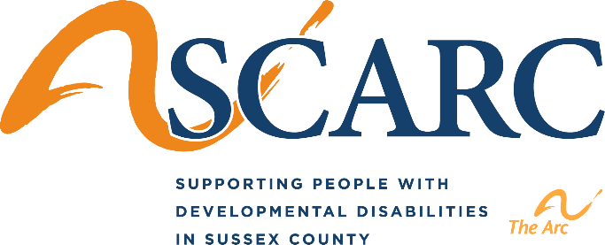

SCARC, Inc. and SCARC Guardianship Services, Inc. invites you to attend an informative seminar on:

“Community Trusts, Special Needs Trusts and the ABLE Act”

Presented by: Megan MacMullin, CEO
SCARC Guardianship Services, Inc.

Tuesday, October 22, 2019

6:00 PM – 7:30 PM

SCARC Hampton Community Center
4 Camre Drive, Newton, NJ 07860

Child care is available by request only.

Please RSVP by October 18, 2019 to: Daele Phlegar at 973-383-7448 ext. 254 or dphlegar@scarc.org

